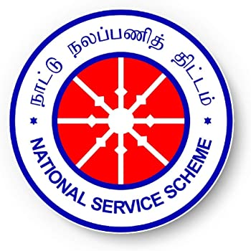

**National Service Scheme (NSS)**

The National Service Scheme (NSS) was officially started on 24th September 1969, to establish a meaningful linkage between the campus and the community. Mahatma Gandhi, the Father of the Nation, had recognised that the country could not progress in a desired direction until the student youth were motivated to work for the upliftment of the villages/community. For Gandhiji, the villages, where majority of the population living, represent the country. Therefore for the national reconstruction and national resurgence it was deemed fit that the students and teachers should be properly sensitised and utilised for strengthening the Indian society as a whole with particular emphasis on rural community. Therefore, student youth, teachers and the community are considered as the three basic components of the National Service Scheme.

**Vision**

The vision is to build the youth with the mind and spirit to serve the society and work for the social uplift of the down-trodden masses of our nation as a movement.

**Mission**

The National Service Scheme has been functioning with the motto “NOT ME BUT YOU” in view of making the youth inspired in service of the people and hence NSS Aims Education through Community Service and Community Service through Education.

**Objectives**

* Understand the community in which they work
* Understand themselves in relation to their community
* Identify the needs and problems of the community and involve them in problem solving process
* Develop among themselves a sense of social and civic responsibility
* Utilize their knowledge in finding practical solution to individual and community problems
* Develop competence required for group living and sharing of responsibilities
* Gain skills in mobilizing community participation
* Acquire leadership qualities and democratic attitude
* Develop capacity to meet emergencies and natural disasters and practice national integration and social harmony

**N.S.S. PROGRAMME OFFICERS (5 Units)**

|  |  |
| --- | --- |
| **Name of the Faculty** | **Department** |
| Prof. S. Pari | English |
| Prof. T. Periathambi | Chemistry |
| Dr. R. Sankar | Commerce |
| Dr. T. Saravanan | Economics |
| Prof. J. Vanitha | Computer Science |

[**N.S.S Activities**](NSS%20Activities.pdf)

**Important Days**

* January 1-7 Road Safety Week
* January 12 National Youth Day (Birthday of Swami Vivekananda)
* January 25 National Voter's Day
* January 26 Republic Day
* January 30 Anti-terrorism Day
* March 8 International Women's Day
* April 7 World Health Day
* May 21 Anti-terrorism Day
* May 31 World No Tobacco Day
* June 5 World Environment Day
* June 26 International Day against Drug Abuse and Illicit Trafficking
* July 8-14 International Literacy Week
* July 11 World Population Day
* August 1-7 World Breast Feeding Week
* August 15 Independence Day
* August 20 Sadbhavana Diwas
* September 5 Teachers' Day
* September 8 International Literacy Day
* September 15 International Peace Day
* September 24 NSS Day
* October 1 National Blood Donation Day
* October 2 Gandhi Jayanthi/Communal Harmony Day
* October 11 World Sight Day
* November 19 National Integration Day
* December 1 World AIDS Day
* December 7 Armed Forces Flag Day
* December 10 World Human Rights Day